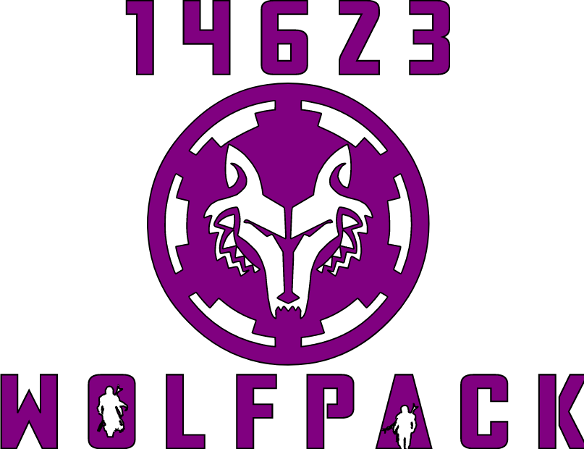
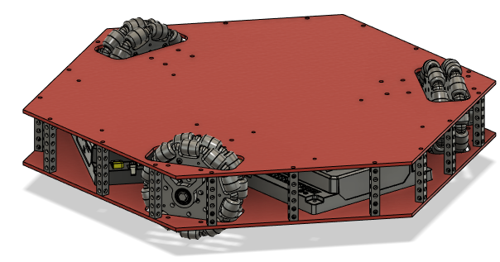
“STEAM IS THE WAY”
Essexville Hampton Cramer Middle School
Essexville, Michigan
1 Team Information 2
2 Team Organization 2
3 Design Process 3
4 Game Analysis 4
5 Concept Analysis 4
6 Robot Architecture 5
7 Chassis and Drivetrain 5
8 Arm 7
9 Climber 7
10 Launcher 7
11 Autonomous 7
12 Programming 7
Code Sharing 8
Subsystems 8
Commands 8
Libraries 8

Team Information
Our team is made up of 15 motivated STEAM focused females that look forward to robotics. We live in the Essexville, Mi area and go to Essexville Cramer Middle School. Our team is managed by the Essexville Garber High School robotics program. The high school robotics program supports all Essexville public school FIRST robotics teams in FLL, FTC and FRC. The FTC team meets 4 days a week in the high school where we utilize the classrooms and professional grade robotics lab. Three main mentors guide, teach, motivate and have fun with us during the FTC season.

Team Organization
Students in FTC meet regularly during the season to design, build and program a competitive FTC robot. All members of the team are organized into 3 different main groups as described below.
- Design – The Design team is responsible for using Fusion 360 to create a detailed design of the robot. Fusion 360 is a professional Computer Aided Design program that easily supports the 3D model creation of a FTC robot. All members of the design team have access to a CAD computer. Almost all components that are needed for a robot are already available for importing into the program. Once imported the component models need to be moved in to 3D space to create our robot to the exact scale and orientation. Some components are created from scratch for manufacturing using our lab or 3D printers.
- Build – The Build team utilizes our robotics lab to fabricate and assemble parts. Students are taught to safely use a wide variety of power and hand tools. Some types of the tools are: screwdrivers, wrenches, rulers, micrometers, hammers, knives, pliers, hand and bench drills, mills, lathes, presses, sanders, chop and table saws, electrical meters, soldering irons, CNCs, wire cutters and vacuums. The design the build team uses is analyzed to gather all the parts that are needed to build the component. If parts are not available in the lab the build team will need to research the possible robotics suppliers for the part or decide to fabricate the part. During concept analysis the build team is responsible for the creation and testing of prototypes that need to be evaluated.
- Programming – The Programming team makes the robot move by writing Java code in Android studio. This team first learns the tools needed to manage FTC robot. These tools are used to upload the program with a PC and configure/update the drive station controller. The programmers learn the basics of the programming libraries and frameworks that are used in FTC. Once the students understand the tools and basics of the high level frameworks they can start learning the Java object oriented programming language. Java is a language that requires simple coding structures and high level object oriented concepts. All students learn at a differently and the approach of tools and frameworks first helps the students become quickly productive and learn the language at there own pace.
FTC is a prelude to the FRC program we hope all students will join. We design, build and program the FTC robots in a very similar way as needed in FRC. The FTC programming experience is almost identical to what is needed for the higher level FRC programming team by using the same language and frameworks. The build and design teams utilize the tools, components and lab that are identical to FRC. Essexville Garber High School supports two FRC teams. One team, FRC 5216, is made of students in grades 9-12 and the other team, FRC 8517, is made of dedicated students in grades 6-8.

Design Process
Resources, knowledge and team involvement affect the design process for an FTC robot. At EHPS we strive to have everything needed to create a world qualifying robot. The following 7 steps are how we attack the design process.
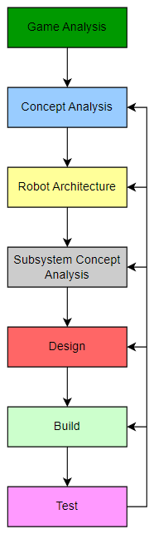
Game Analysis
During this step we analysis the game points, expected team playing strategies and determine the tasks a robot should perform. We use the tasks and point values to rank the tasks based on difficulty to achieve the task. The task difficulty ranking and point values are used to help prioritize the remaining design process.

Concept Analysis
Using the game analysis results we develop an assumption of what we think the abilities of a perfect robot would be able to do in a match. These abilities are listed out and we evaluate and select which ability we will strive for. The mentors and students discuss what we will do for our robot based on student and mentor capabilities.

Robot Architecture
Now that we have a concept of what our robot needs to do we break up our robot into manageable pieces. We call these pieces that make up our robot an architecture. This robot architecture is usually a set of physical parts of the robot that perform one particular function. Since we understand our robot architecture, pieces, functions and physical parts we can start assembling them into a robot picture that turns into our robot design. Another term we use for our physical parts of our robot is subsystems. Our complete robot is called a system and it is made up of subsystems.

Subsystem Concept Analysis
In a brainstorming session with all the students we develop ways that a physical mechanism can perform the needed subsystem function. A decision matrix is used to compare the promising different mechanism based on our selected criteria. At this point we develop a list of functions and criteria the subsystem must achieve.

Design
The selected subsystem from the subsystem concept analysis enter the design phase. The students work on the individual subsystems design in Autodesk Fusion 360. The Mentors work as high level system designers and create the design of the entire robot with the student subsystems. This tight interaction between mentor and student supports a nice learning experience and limits mistakes in the final robot.

Build
When known parts of the subsystems are done being designed the build team creates the parts in the lab. Subsystem parts are ordered, created and assembled on the final robot. Design changes based on build constraints are forwarded back to the design team for updates to the CAD model. Building in our lab consists using tools like: CNC, 3D Printer, Table Saw, Chop Saw, Mill, Lathe, Paint booth, Drill, Sander, Press, Bender, and various Hand Tools.

Test
All subsystems are tested individually or with the entire robot to see if they meet the expectations of the original requirements. If the tests do not pass, the design process will start back over at an earlier stage or the subsystem capability is accepted.

Game Analysis
This years game analysis was done with the team to create a point analysis to support our concept decisions. We created game strategies from using the field and doing a mock game play with the students pretending to be a robot. Since Driver Control consists of only one task the game strategies were limited to picking up pixels and placing them on the backdrop. A simple point analysis of what a single robot can achieve shows that a lot of the points can come from Driver Control if pixels were placed on the backdrop. Since many of the points can come from Autonomous and End Game the tasks in those game periods are a priority.

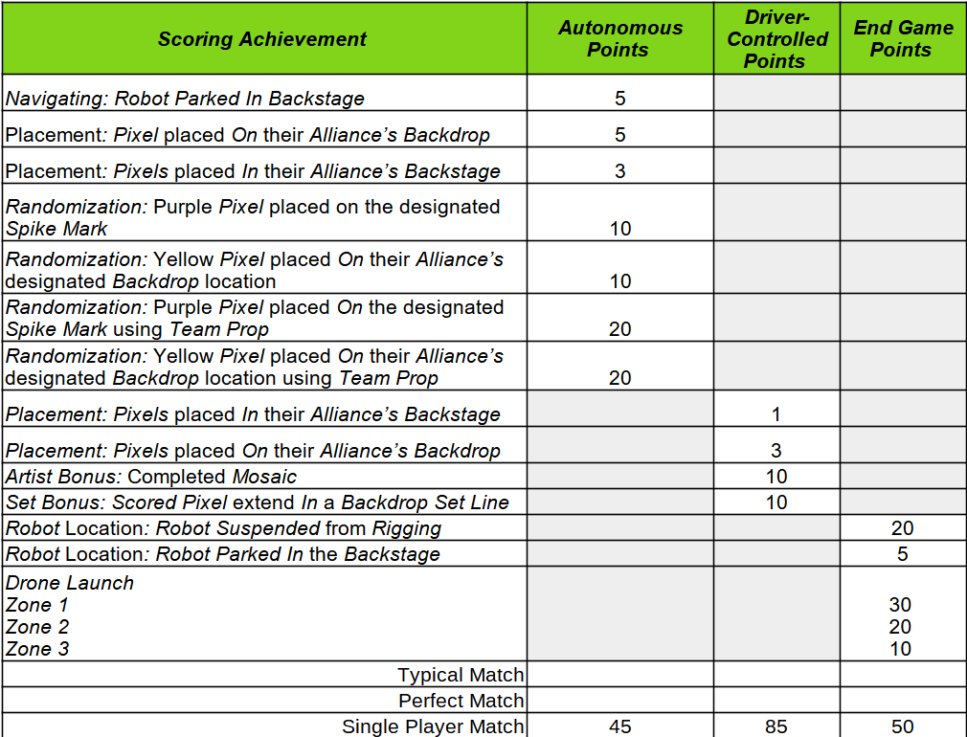
Concept Analysis
Our assumption of what a perfect robot can achieve is summed up in the following list.
Autonomous | Driver Control | End Game
- Score yellow pixel on designated  spike mark using game prop.  - Score purple pixel on designated  backdrop location using game prop  - Score 4 white pixels | - Traverse the field to score  2 pixels in 6 seconds  - Score pixels in all areas of  the backdrop | - Climb on rigging in less that 5  seconds  - Launch drone in 30 point  location in 1 second
Since our team has the tools, equipment, supplies, knowledge and time to achieve all the tasks listed we will strive to complete all the tasks. The most difficult task in the list is the Autonomous “Score 4 white pixels”. Identifying this difficult task at the beginning allows us more time to focus on ways to accomplish the task.

Robot Architecture
Our Concept Analysis has defined many tasks or functions our robot must do to be the robot we want to compete with. To meet the robot abilities we created the following architecture or breakdown of the robot. Our robot is composed of a chassis, drivetrain, climber, launcher and arm.
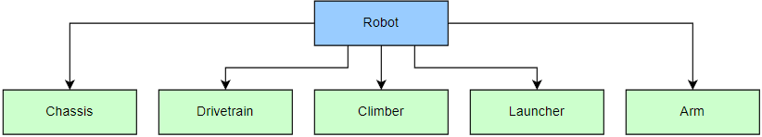

- Chassis The chassis supports all the defined subsystems by holding them together.
- Drivetrain The drivetrain is responsible for moving the robot around the field.
- Climber The climber is only responsible for the end game function of raising the robot on the rigging.
- Launcher The launcher performs the functions of making the paper fly to zone 1 and holding the plane.
- Arm The arm handles the functions of picking up, holding and placing pixels.

Chassis and Drivetrain
To meet the game and concept analysis our chassis and drivetrain must prioritize high speed, agility, small size, style, stability and maneuverability.
- Concept Analysis
The following table shows an analysis based on our important criteria. The winner of the analysis was the 3 wheel Killough/Kiwi concept.
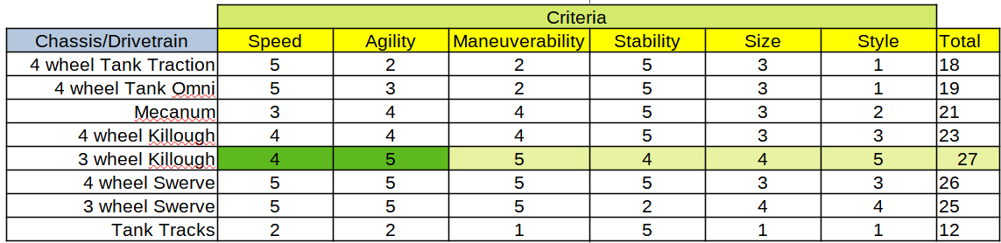
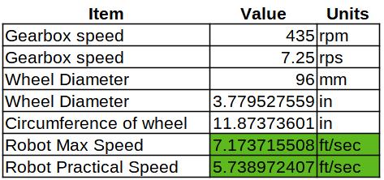
The 3 wheel Kiwi/Killough design is what we decided to create. We developed a set of needs or requirements the chassis and drivetrain must meet.
+ Style – The chassis must be unique to this years game in some way.
+ Speed – The speed of the drivetrain must travel at least 5 feet per second.
+ Agility – The drivetrain must move the robot in any direction quickly.
+ Maneuverability – The drivetrain and chassis must be small enough to easily and quickly go through the truss structure.
+ Size – The chassis must be small enough to support the width and height needs to manage all areas of the truss structure.
+ Stability – The chassis and drivetrain must be stable enough to prevent the robot from tipping over during all movements.
-Design
To meet the requirements from our concept analysis we created a chassis that was in the style of a pixel to meet this years game theme. The size of the chassis was made much smaller than the max limit or 18”. A lower plate was added to our chassis to hold our electronics and add stability by being low to the ground which prevents the robot from tipping over. Our drivetrain of a 3 wheel killough supported our agility and maneuverability by being omni directional. The table the right shows our calculations that prove our drivetrain should achieve the speed needs of 5 feet/second.
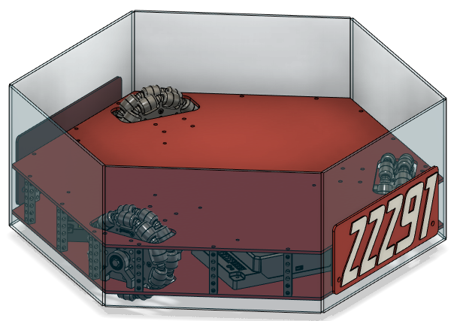
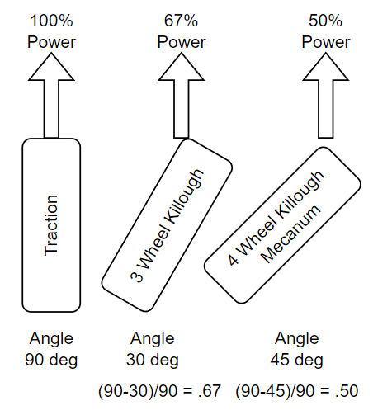
A further analysis of the wheel type was done to confirm that the 3 wheel Kiwi drivetrain was a good choice. The diagram to the right shows different power expectations that are achieved with different wheel arrangements. A typical tank drivetrain has 100% power when rotated. A 3 Kiwi arrangement has the wheels 120 degrees apart from each other, therefore forward movement has the wheel at 30 degrees from straight ahead. With a 30 offset from normal the arrangement results in 67% of the power supporting forward movement. A 4 wheel Kiwi or Mecanum arrangement will result in only 50% of the rotational power supporting forward movement. During normal movement two wheels supply most of the power to move the robot with a 3 wheel Kiwi drive.
One more advantage we observed from testing out a 4 wheel Kiwi drive was that a 3 wheel system drives more accurately. This was surprising to us and we contributed it to wheel engagement for a 3 wheel Kiwi is better than a 4 wheel Kiwi. A chassis must be very stiff and accurate for all 4 wheels to be in contact with the floor. A 3 wheel Kiwi drive does not have this problem since the robot can not balance on 2 wheels.
Last years robot used the 3 wheel Kiwi design and it was very light. One disadvantage to only having 2 motors drive the robot is total power output needed may exceed the stall torque of the motors or battery capability. We added a 25 pound weight to the robot and tested the current and speed capability of the robot. We noticed that the current draw was much higher and the max speed was much lower. The robot was able to drive for 3 minutes with a full battery. We determined we have the following options to help with the high current draw of only using 2 motors.
- Keep the robot light by using plastics and optimizing the subsystems.
- Lower the motor gear ratio to 312
- Lower the omni wheel diameter to 72mm
We decided to keep the 435 RPM motors and 96mm wheels. Our goal is to reduce weight as much as we can. Our base pixel style chassis was designed to support 72mm wheels if we found out we needed them after testing.
- Build
- Test

Arm
- Concept Analysis
After our game analysis we decided that our arm must meet the following criteria and requirements.
o – The arm shall stay under the minimum truss height while driving during the match.
o – Shall follow all the rules in the game manual.
o – Shall pick up two pixels at a time from from the floor and 5 stack locations.
o – Shall drop off one pixel at a time on the highest set line position of the backdrop.
o – Shall be able to move from any position to the drive position within 1 second.
o – Shall be able to quickly pickup and drop off pixels. Quickly means less than 1 second to get or release the pixel.
o – Shall be visible and easy for the driver to line up the robot with the pixel.
o – Shall be robust enough to handle collisions with the field and other robots.
- Design
- Build
- Test

Climber
- Concept Analysis
During our discussions about the climber we developed the following ideas for possible climber mechanisms.
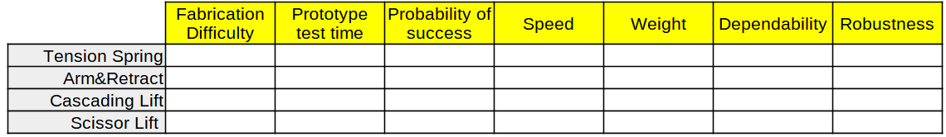
Based on our climber needs we developed the following guidelines, criteria and requirements the climber design must meet.
o – The climber shall stay under the minimum truss height during the match and may extend at end game.
o – Shall follow all the rules in the game manual.
o – Shall raise the robot at least 6 inches off the ground in 3 seconds after the hook is placed.
o – Shall allow the driver to run into the top of the truss without damaging the climber
o – Shall limit the climb height to prevent robot damage.
o – Shall allow for grabbing the truss from at least 2 directions.
- Design
- Build
- Test

Launcher
- Concept Analysis
During our launcher brainstorming session we developed 3 ideas for ways of scoring the drone in the 30 point area. These ideas were ranked based on the criteria we decided on.
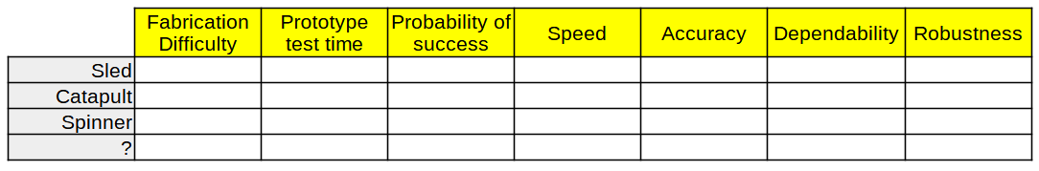
Based on our robot and scoring needs we developed the following guidelines, criteria or requirements the launcher design must meet.
o – The launcher shall stay under the minimum truss height during the match and may extend at end game.
o – Shall follow all the rules in the game manual.
o – Shall score the drone in the 30 point area.
o – Shall launch the drone in less than 2 seconds after the robot has positioned itself.
o – Shall protect the paper drone from damage during a collision with another robot or field element.
o – Shall score in zone 1, 9 out of 10 times during practice.
o – Shall be adjustable manually, before-setup, to compensate for competition areas that have unexpected air movement.
- Design
- Build
- Test

Control
The basic Driver Control of our robot is accomplished with a driver and operator using game controllers to driver the robot and interact with the software and electronics to manipulate the mechanisms. The controller setup for the driver, left, and operator, right, is shown below.
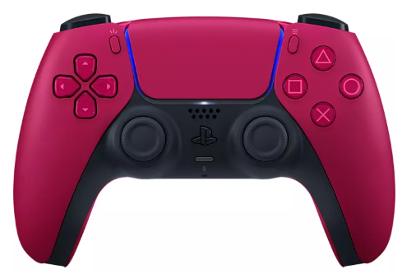
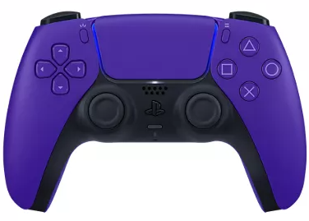
Our three wheel holonomic drivetrain, otherwise known as a "Kiwi" or "Killough," is a drivetrain with omni directional motion while utilizing three omni wheels. The drivetrain code utilizes vector math to calculate the three different wheel speeds from the inputs given by the drive controller left thumb stick, autonomous values and gyro. The gyro is used to allow the driver to operate the robot in what we call field oriented mode. Field oriented mode uses the gyro to compensate for the heading of the robot while driving. This gyro compensation allows the driver to use to thumbstick to tell the robot which direction on the field to travel no matter what direction the front of the robot is pointed. The following illustration helps explain the idea.
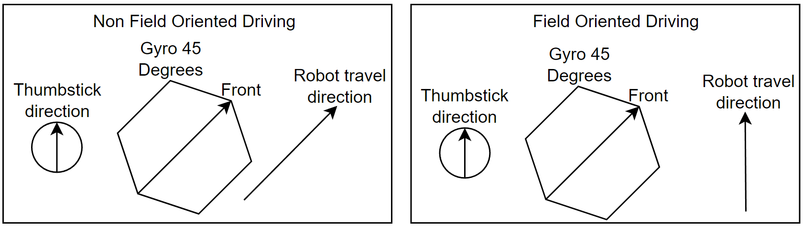
During Driver Control we use the following sensors and software to enhance our robot control.
+ Arm – The rotation and extension code reads the motors encoder to limit the angle or rotation.
+ Lift – The lift motor code reads the motor encoder to determine the distance to extend and retract.
+ Drivetrain –
The drivetrain uses motor encoders to determine distance traveled in autonomous and velocity control for Driver Control.
During autonomous we use the camera as a sensor to do object detection on our Team Prop to score a yellow pixel.
The camera is also used to sense the correct April Tag to score a purple pixel. Utilizing the camera allows us to determine the
distance and angle of the robot when sensing the April Tag. Those readings are then used in code to move the robot left or right to position the robot for scoring. Located on the bottom of the robot is a color sensor. This color sensor is used in Driver Control to quickly sense the color of the backstage tape. The tape color sensing is used to stop the robot in Driver Control from moving farther towards the backdrop so we do not accidentally crash into the backdrop. The following images help explain the usage and outcome of our autonomous routines.


Programming
Programming at EHPS for an FTC robot is done using Android Studio and the Java programming language. We utilize the FTCLib libraries from www.FTCLib.org. The FTCLib library allows us to create code that is very similar to FRC code that uses the command based programming framework. A snippet of this years code structure is shown in the image on the right. At the root of our “teamcode” folder we store our OpModes for Driver controlled and autonomous. We then separate our code into folders to store our Commands, Subsystems and Libraries. The Subsystems folder contains our subsystem java classes. The subsystem java classes contain all the methods and data needed to control that particular subsystem. The Commands folder contains the Default Commands for each subsystem, Commands to control a subsystem and Autonomous Command Groups. Many generic libraries are created while developing the code and those libraries are stored in our Lib folder.

Code Sharing
All of our code is stored at our public GitHub repository for other teams to utilize as a learning resource. We also use the GitHub repository as a storage and sharing utility between programmers within EHPS. The utilization of GitHub allows the student programmers and mentors to work together on the large project. Our repository for this years code can be found at. https://github.com/dgreathouse/2023-FTC-CenterStage.git

Subsystems

